**Day 12**

**Deploying NodeJS app on AWS EC2**

First before deploying app to servers, we need to test locally. In order to test locally we need to have the NodeJS app in our local.

Getting app in our local PC:

1. Download zip folder of the app from GitHub repo into our local PC.

GitHub Repo URL: <https://github.com/verma-kunal/AWS-Session>

1. Use Git Bash Terminal and git clone command. Change to the target directory before cloning.
2. Open VS code and in Terminal select Git bash or Command prompt and use git clone command. Change to the target directory before cloning.

**Let’s try second method:**

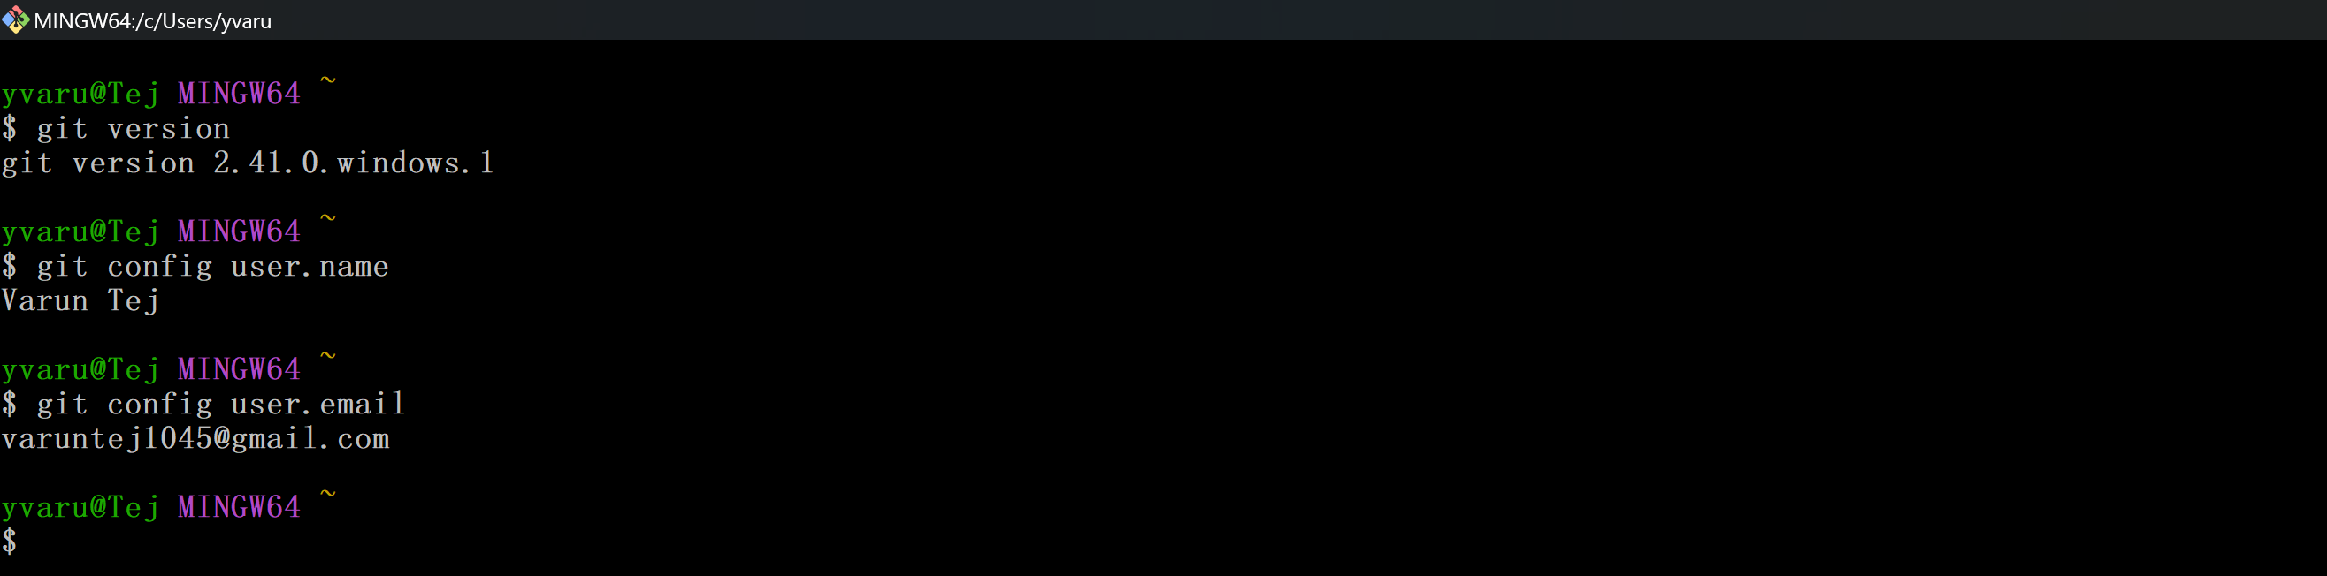Git Bash is already downloaded and configured. Now we have to change the directory where we want to store the application that we will be downloading from GitHub. Use cd commands. Then use got clone command. Now we have to open the code using VS code. Can give ‘code .’ command it will open in VS code directly. Or you can open VS code and manually load the app.

**Trying 3rd method:** This is also similar to second method only but the difference is we are using the same terminal in VS code. But executing the same commands.

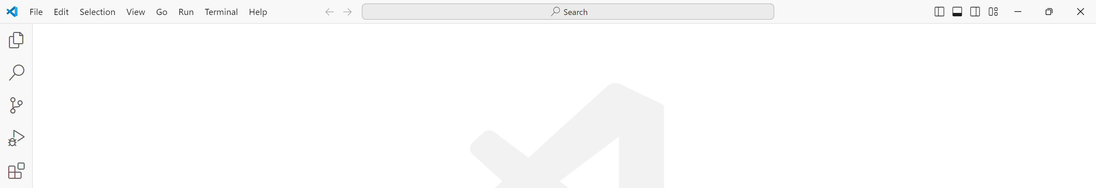 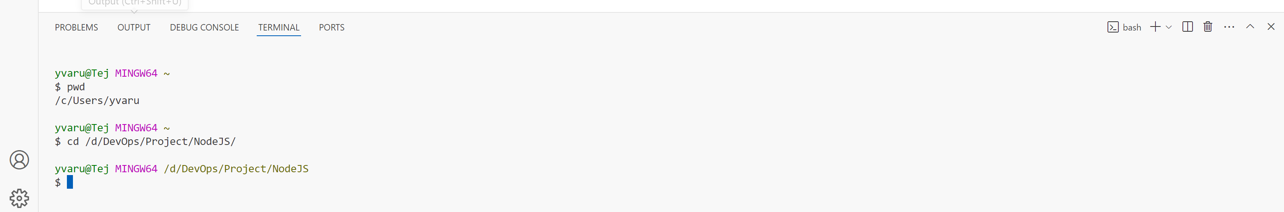

We changed the target folder in order to clone the GitHub repo. 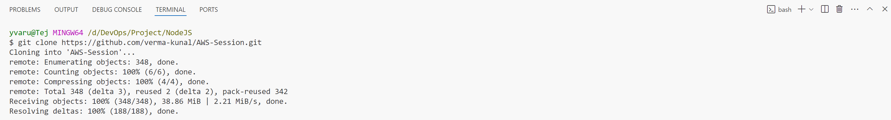

App is in our local now in destined directory. 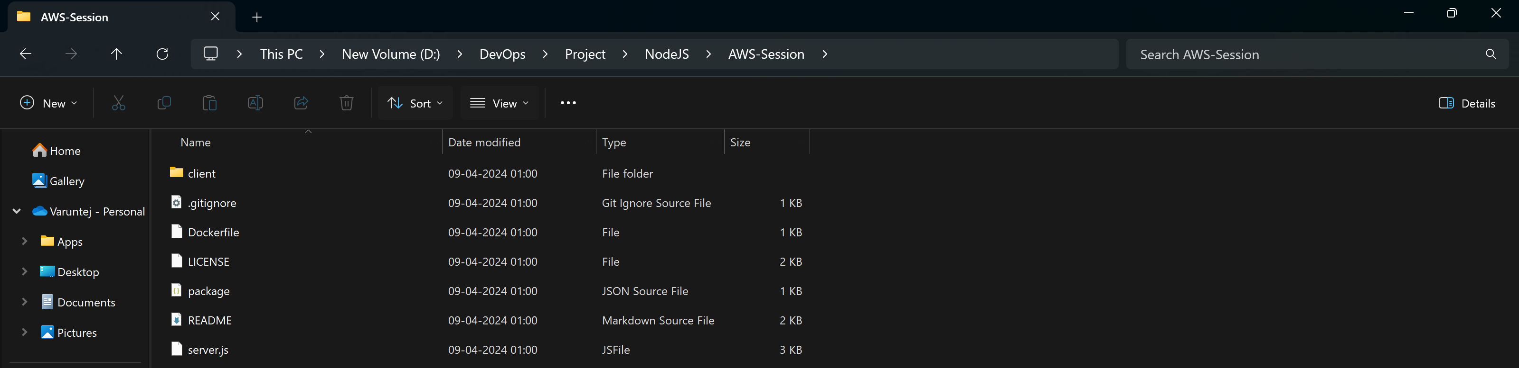Change the directory to AWS-Session 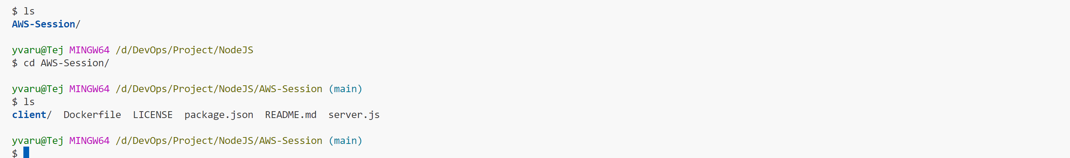

Enter **“code .”** to open the codebase in VS Code. It will open new instance of VS code and can open terminal again. 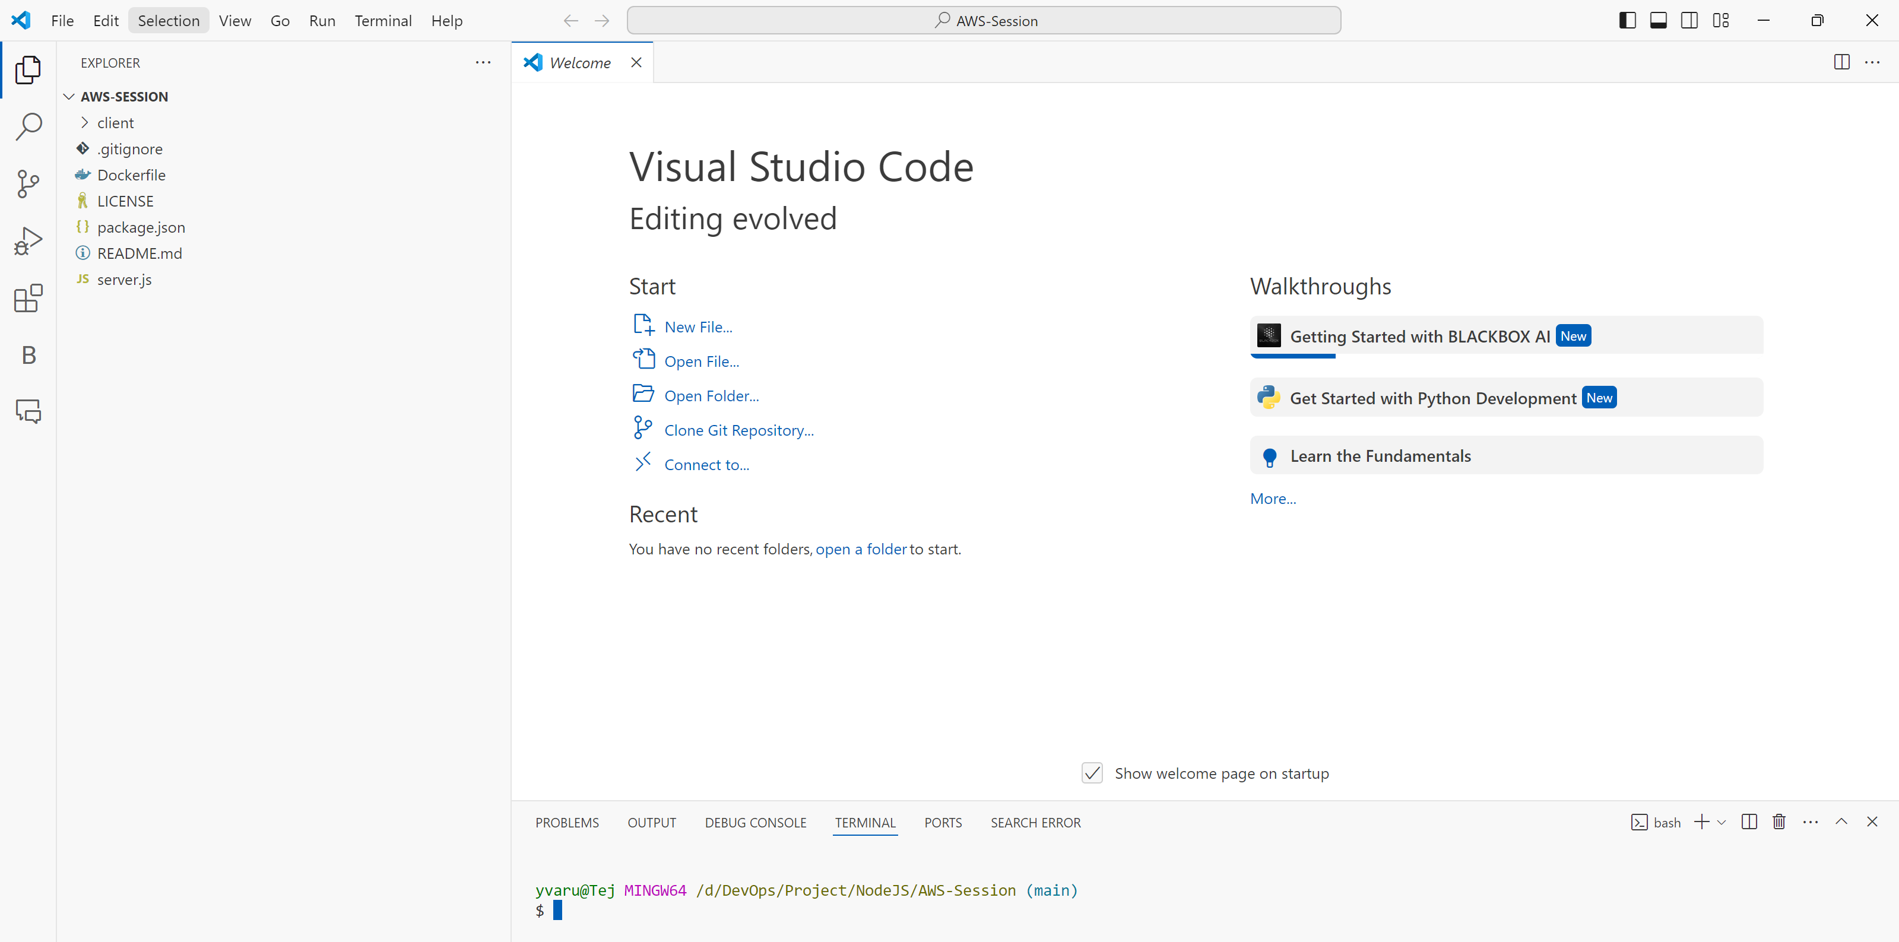

Create an **“.env”** file for declaring environment variables that will be used multiple times. 

Add this code in **.env** file: 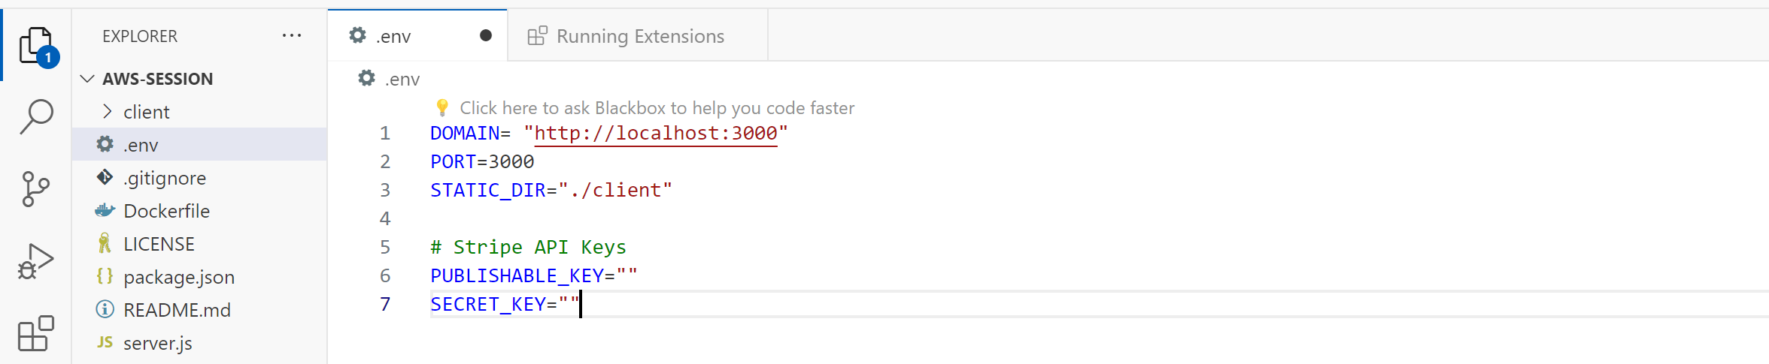

Now, we have to add Stripe API keys: Stripe API keys are used for integrating Stripe's payment processing services into web or mobile applications. Stripe is a popular payment gateway that allows businesses to accept payments online securely and easily.

Go to stripe.com or <https://dashboard.stripe.com/test/dashboard> can see both Publishable and secret keys.

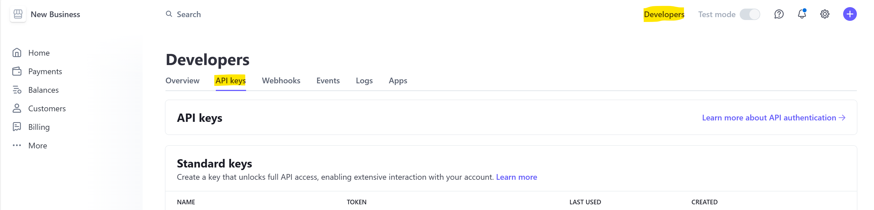

Add both of the keys in “.env” file and save it.

**Now we have to install NPM (node package manager):** npm is used to manage project dependencies. You can easily install, update, and remove packages directly from the integrated terminal or using the built-in npm tools.

We need to have Node.js and npm installed to run node.js app.

**Node.JS is a open-source, cross-platform JavaScript runtime environment that executes JavaScript code outside of a web browser.**

By installing Node.JS it will also install npm package manager.

Downloading Node.JS: <https://nodejs.org/en/download> Once downloaded, open the file and proceed with next button. Do not select “download additional tools chocolaty, python”. It will execute a script and install lot of tools.

Once Installed open any command prompt terminal or in the same VS code terminal check Node JS and NPM versions with **“node --version” & “npm --version”** 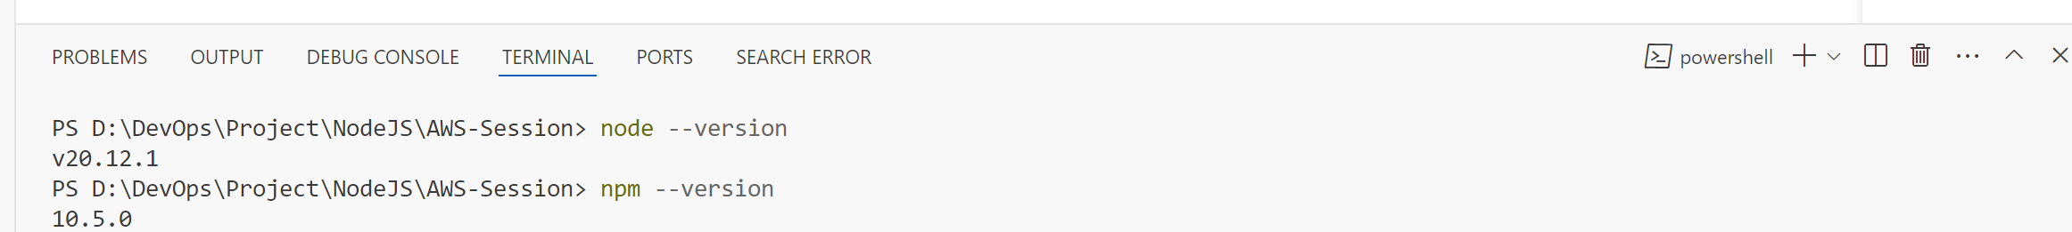

If not able to see the version number, then it seems that node js is still not recognized in PowerShell/git bash/ cmd. Let's ensure it is properly installed and the **PATH** **environment** **variable** is correctly configured.

Since it is installed successfully. Let’s check the PATH Variable.

**Setting PATH for Node JS:**

Search for “Edit the system environment variables” in local PC and then open it.

Go to Advanced 🡪 Environment Variables 🡪 System variables 🡪 **PATH**

Select that **PATH** and click on Edit. It should have nodejs path configured in it. If not then we have to add that in new row. To add that we need to know where the node js directory is in our PC. Know that during installation. Add that folder path clicking on browse and select that folder. It will add.

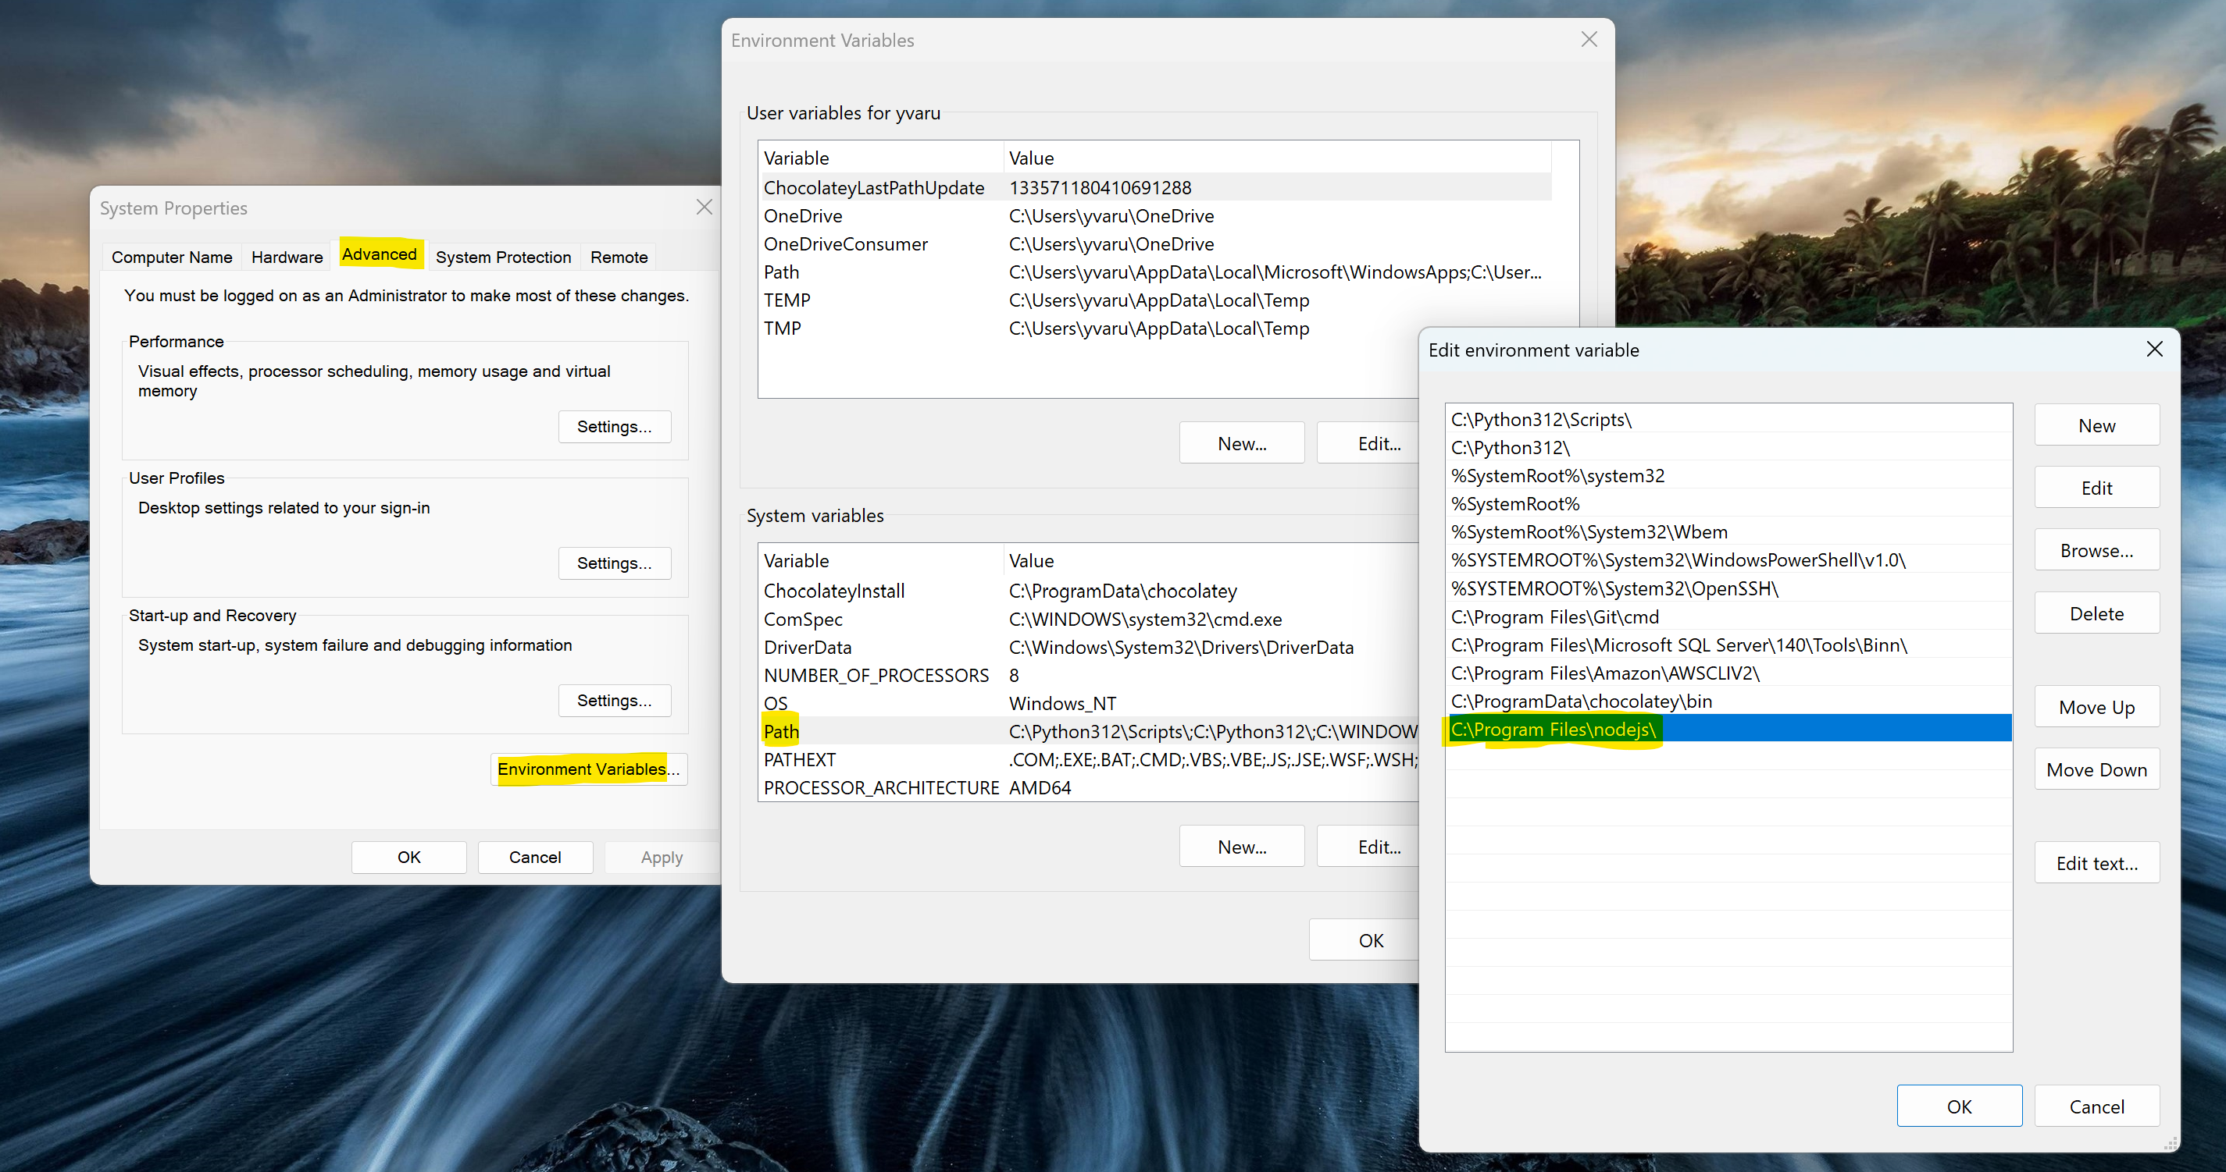

If the PATH is already configured then just restart the PC. It will work.

Give **npm install** command so that it will download all the dependencies for the project.

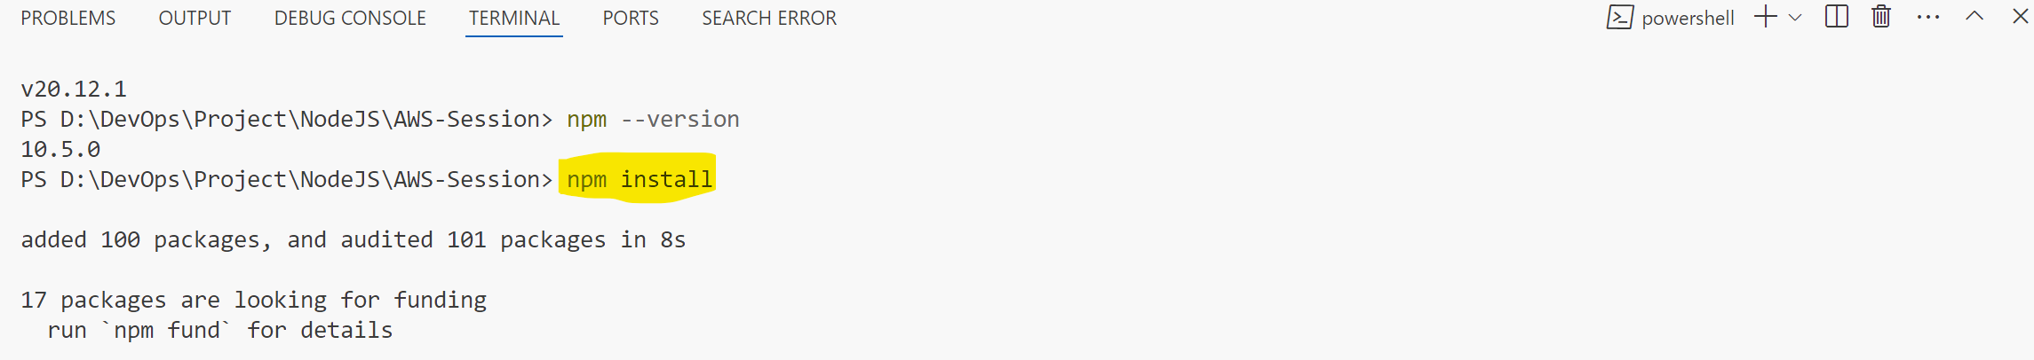Node Modules folder will be created and it will have all the dependencies.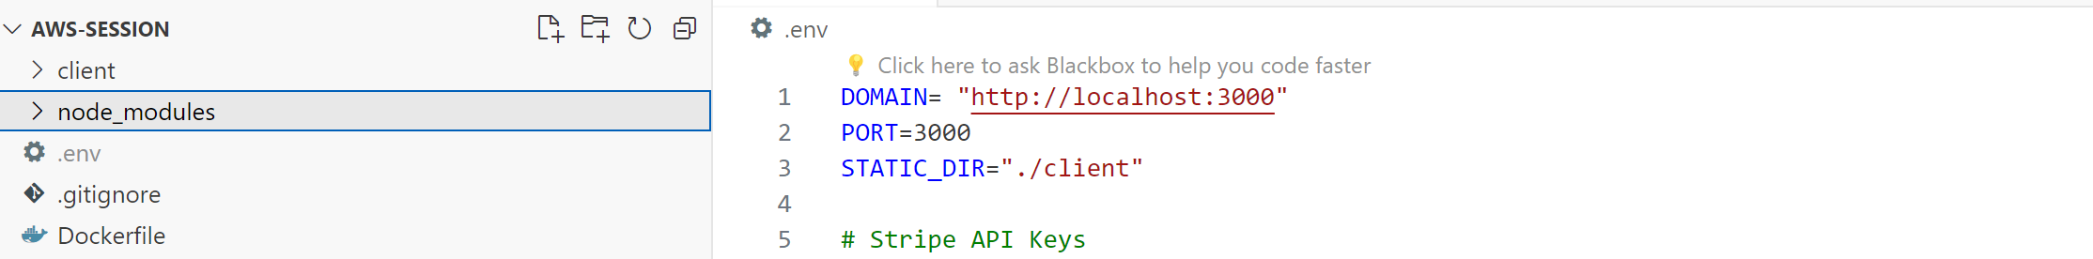

Now, give **npm run start** is a command used to execute a script named "start" defined in the "scripts" section of a project's package.json file. 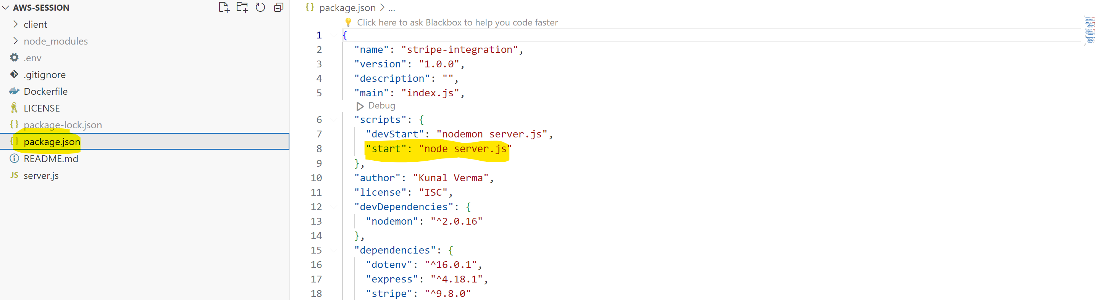

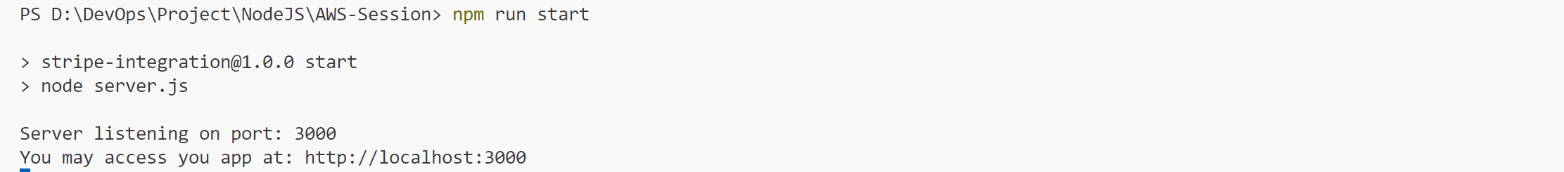

Now, paste the URL in any browser. 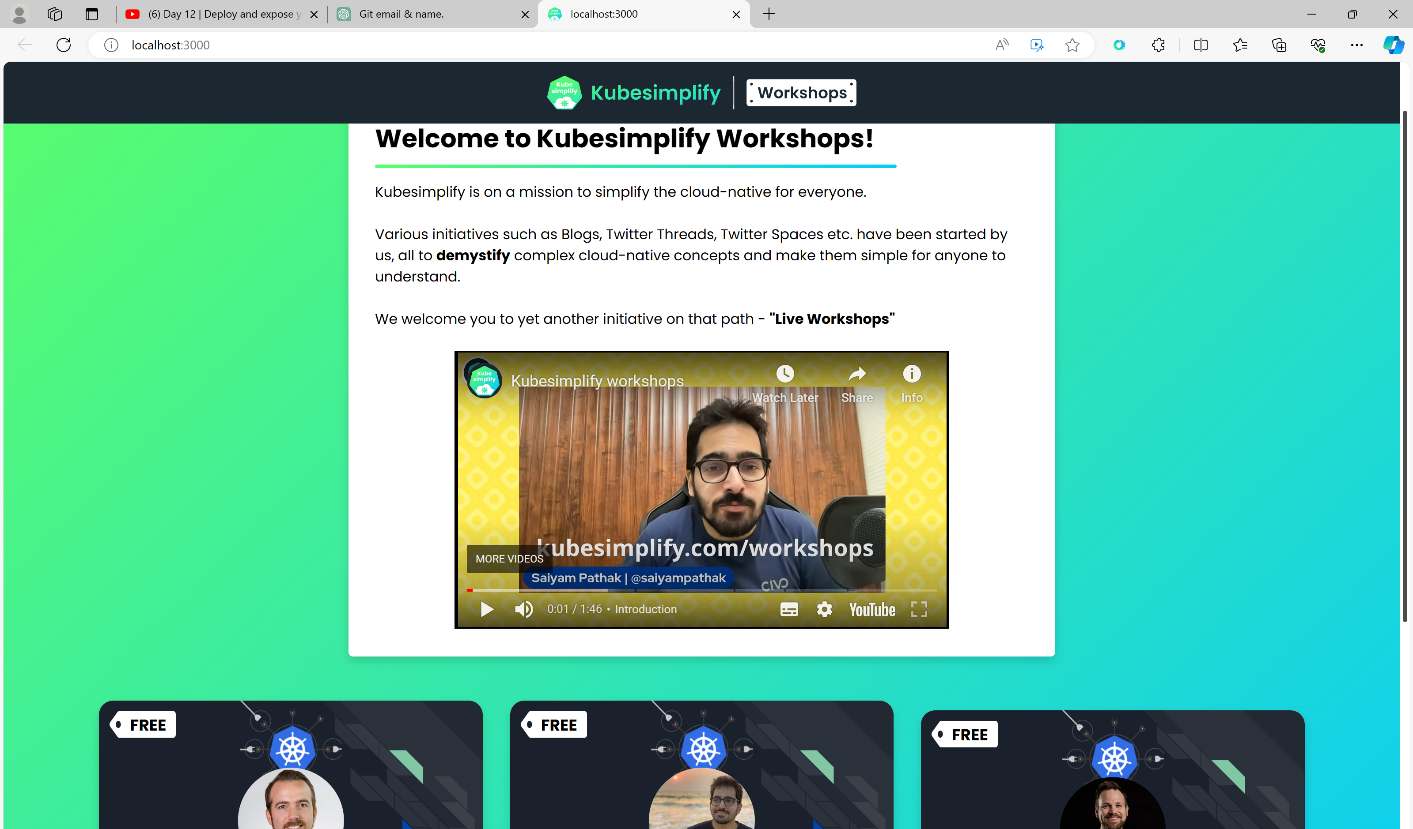

To stop running the app in local server press “CTRL + c” and give ‘Y’.

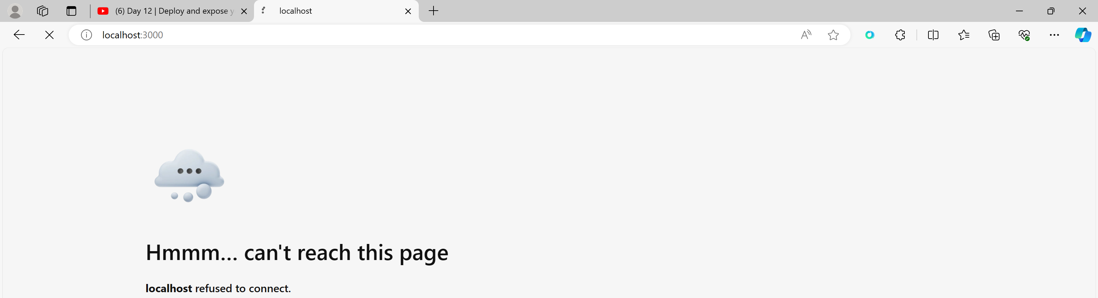

Local testing is done. Now we havee to **deploy** this **application to AWS.**

**Creating IAM User and add Admin permissions to him:**

Instead of using root user, we always have to prefer using roles. Even in any organisation we will get the users and roles only not the admin access.

Login to AWS Console and go to IAM Servives: Create a new user and mark the checkbox below. 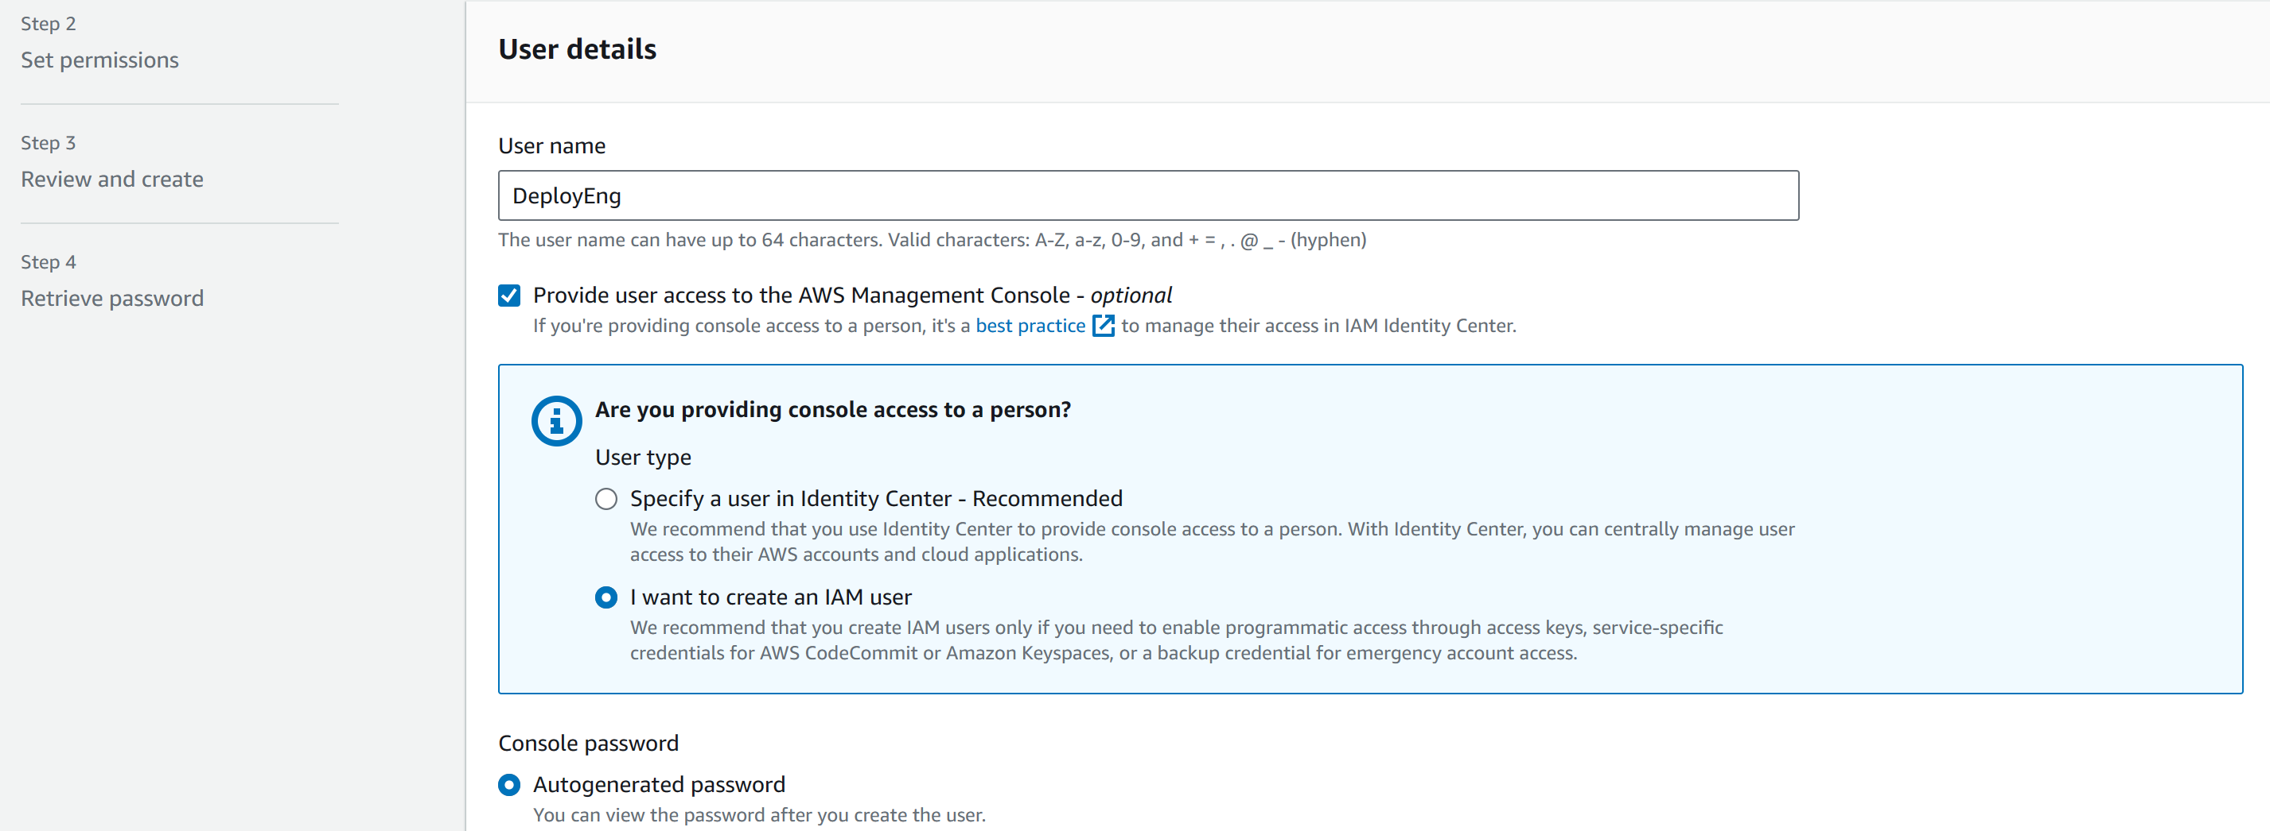

Create custom password.

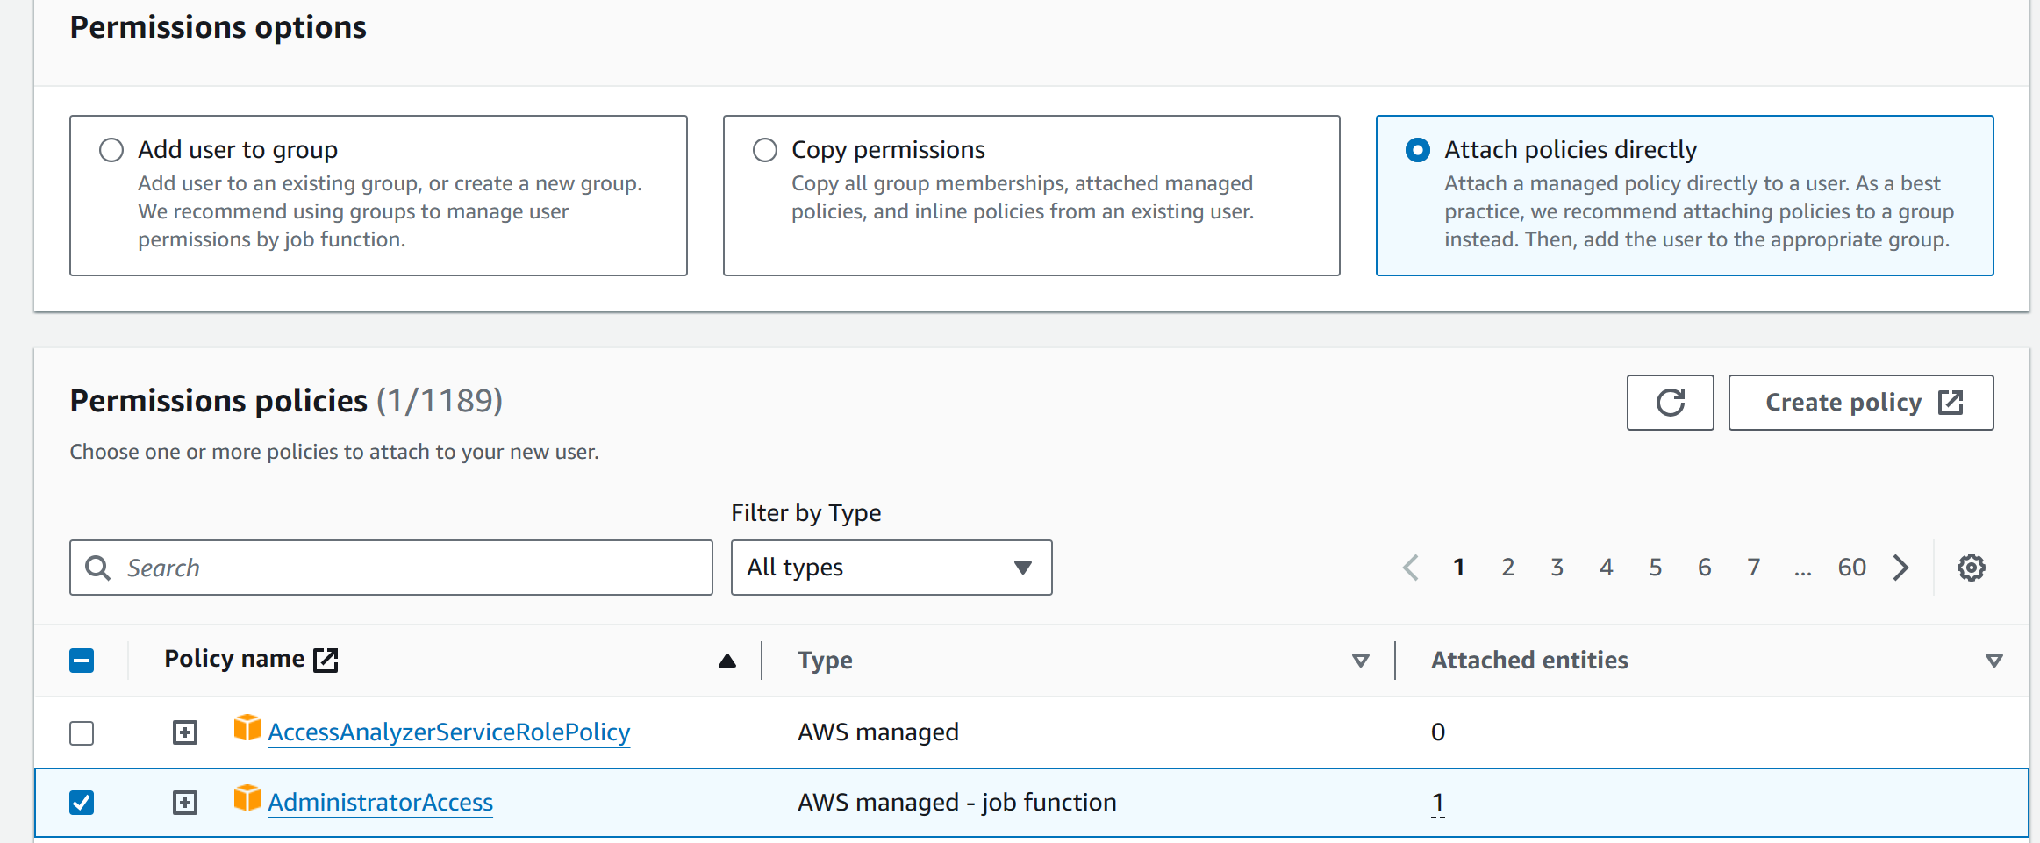

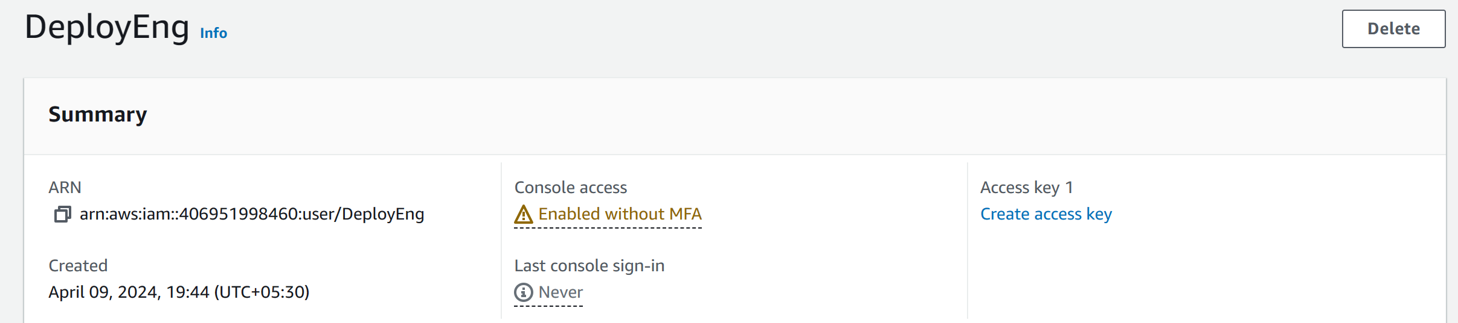User with Admin Access is created. Now login to the AWS cosole using this User. Copy the Console Sign-in link from below. And signin to the AWS console.

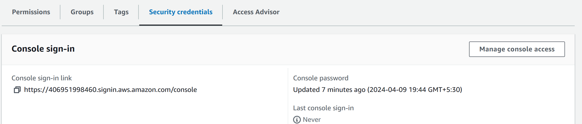

**Logged in with IAM User:**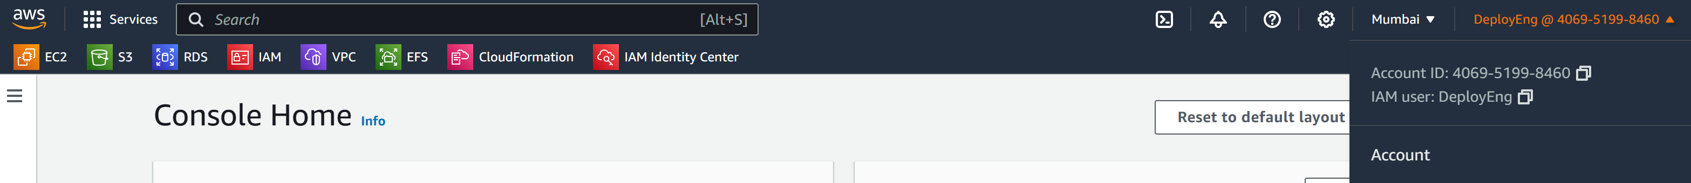

**Creating EC2 Instance:**

Now, create an EC2 Instance using Ubuntu 22.04 LTS (Latest one) AMI.

Create EC2 with Key pair: Key pair type – RSA; private key file format – “.pem”

SecurityGroup:

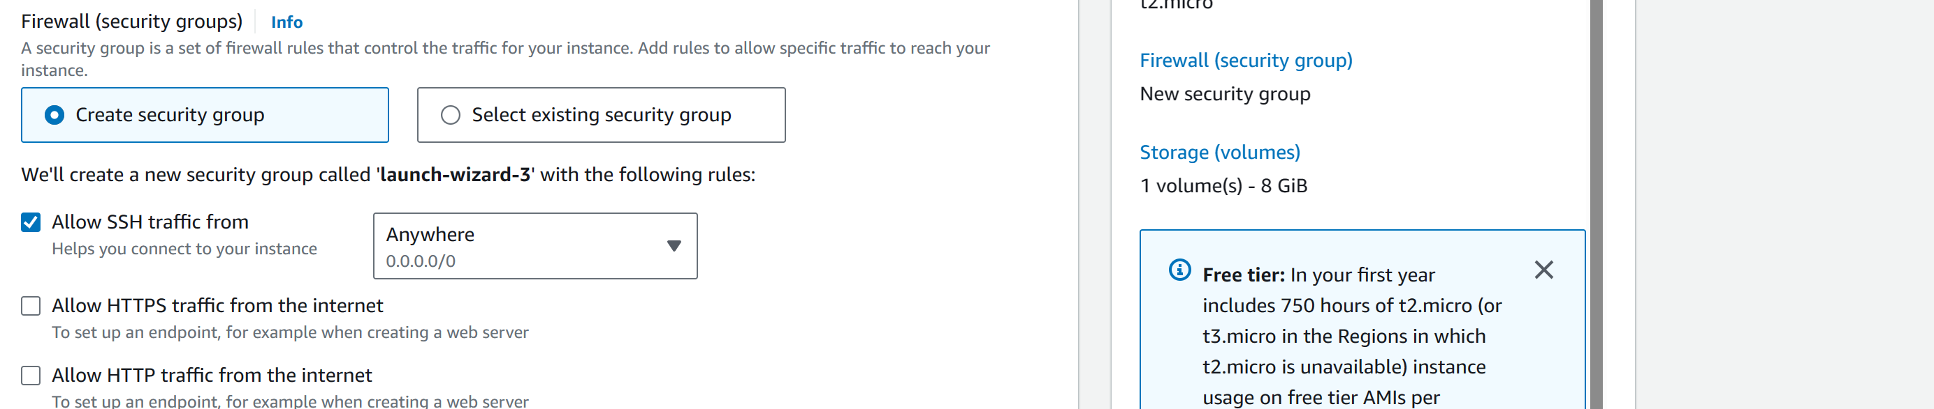

EC2 Instance Created: 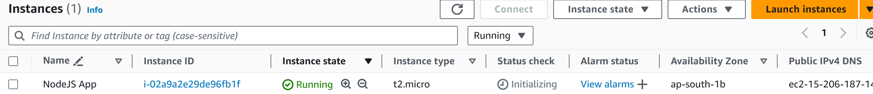

**Connect to the instance:**

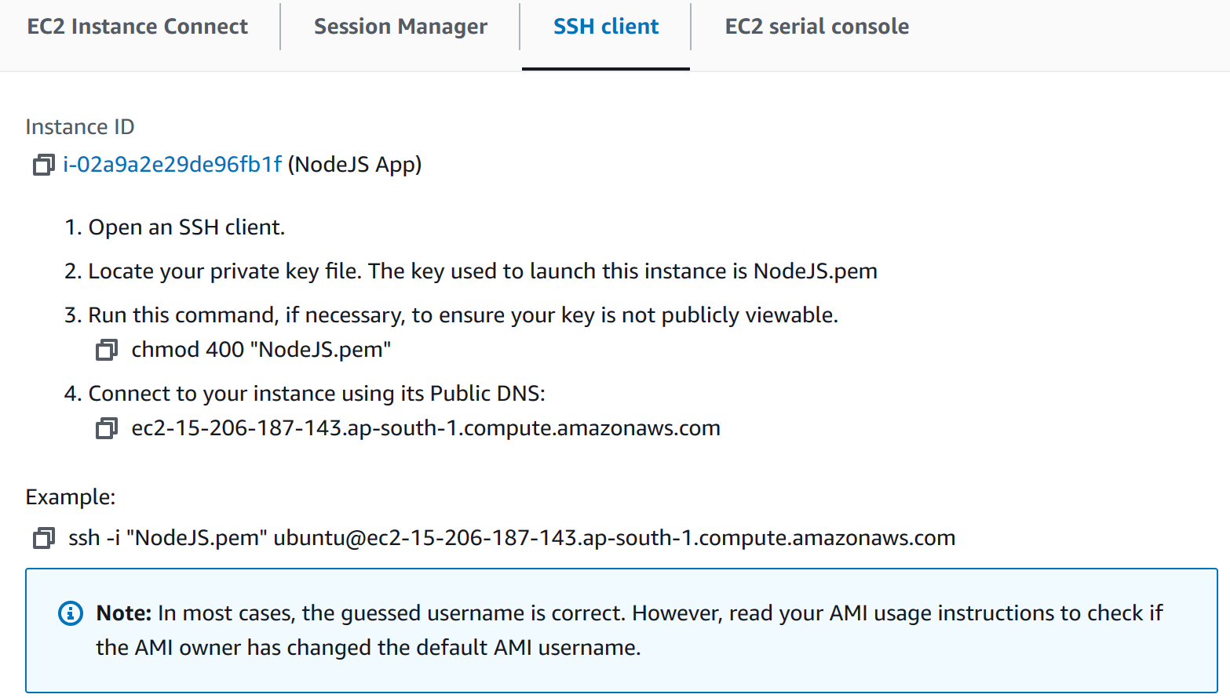

My Pem file is in Downloads. So, I opened terminal from that directory.

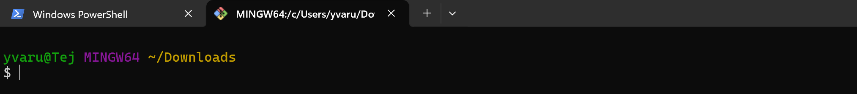

Now execute this command:

**ssh -i "NodeJS.pem" ubuntu@ec2-15-206-187-143.ap-south-1.compute.amazonaws.com**

**or ssh -i NodeJS.pem ubuntu@15.2.6.187.143**



**Configuring Ubuntu: GIT, Node.JS, NPM**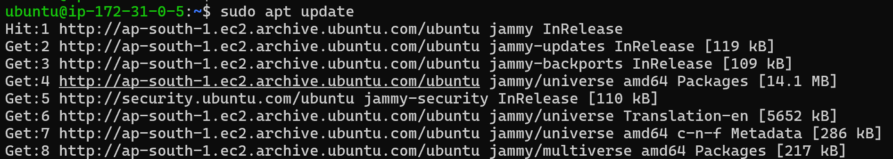

Have to install **GIT, Node.JS and NPM.**

Since, we selected latest ubuntu AMI, it had GIT pre-installed. 

Ubuntu 22.04 contains a version of Node.js in its default repositories that can be used to provide a consistent experience across multiple systems. At the time of writing, the version in the repositories is 12.22.9. This will not be the latest version, but it should be stable and sufficient for quick experimentation with the language.

Install **nodejs** using **sudo apt install nodejs**

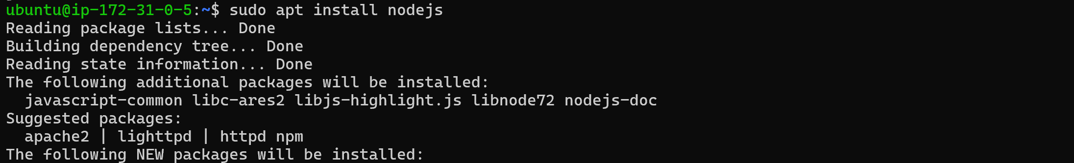

To check the version: **node -v **

Install **npm** using **sudo apt install npm**



To cheeck the version: **npm -v or npm --version**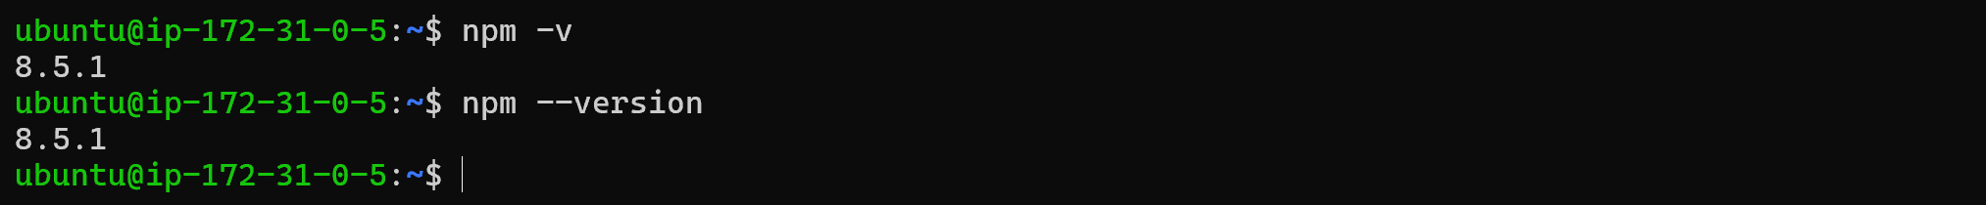

**Deploying Project on AWS EC2:**

Clone the Project repo to EC2 instance using **git clone repo_URL**

**Repo URL:** [**https://github.com/verma-kunal/AWS-Session.git**](https://github.com/verma-kunal/AWS-Session.git)

**Command:** git clone https://github.com/verma-kunal/AWS-Session.git

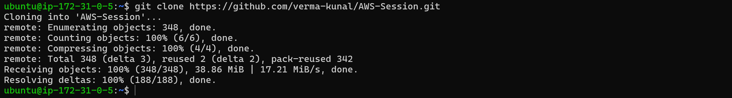



Now, we have to set up environment variables just like how we did in our Local.

To do that change directory to AWS-Session folder and then create **“.env”** file.

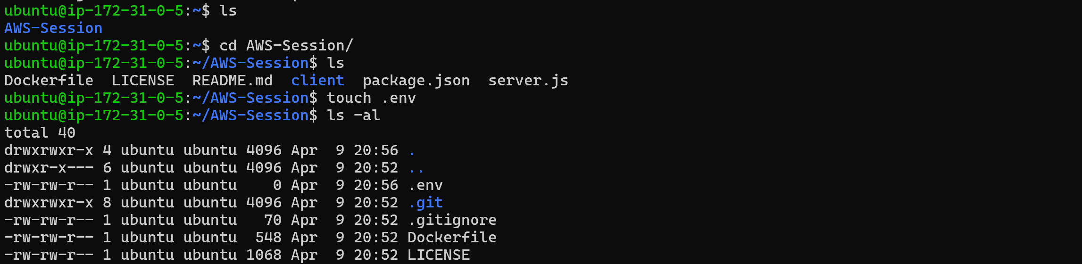

Now, edit the ‘.env’ file and add these lines: **Command – vi .env**

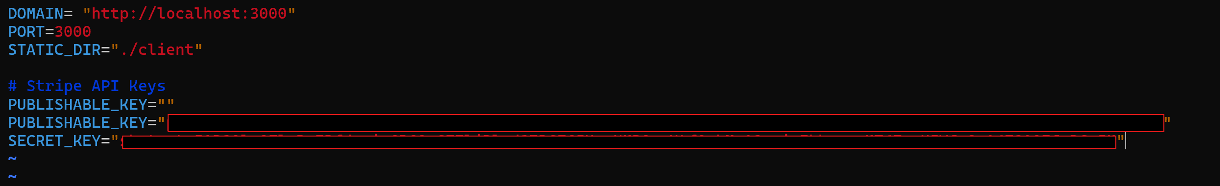Copy the same code that used for local tetsing in VS code.

**Initialize and start the Project:** Now, we have to install the node modules folder for the packages that we need for our app.

**Command:** npm install

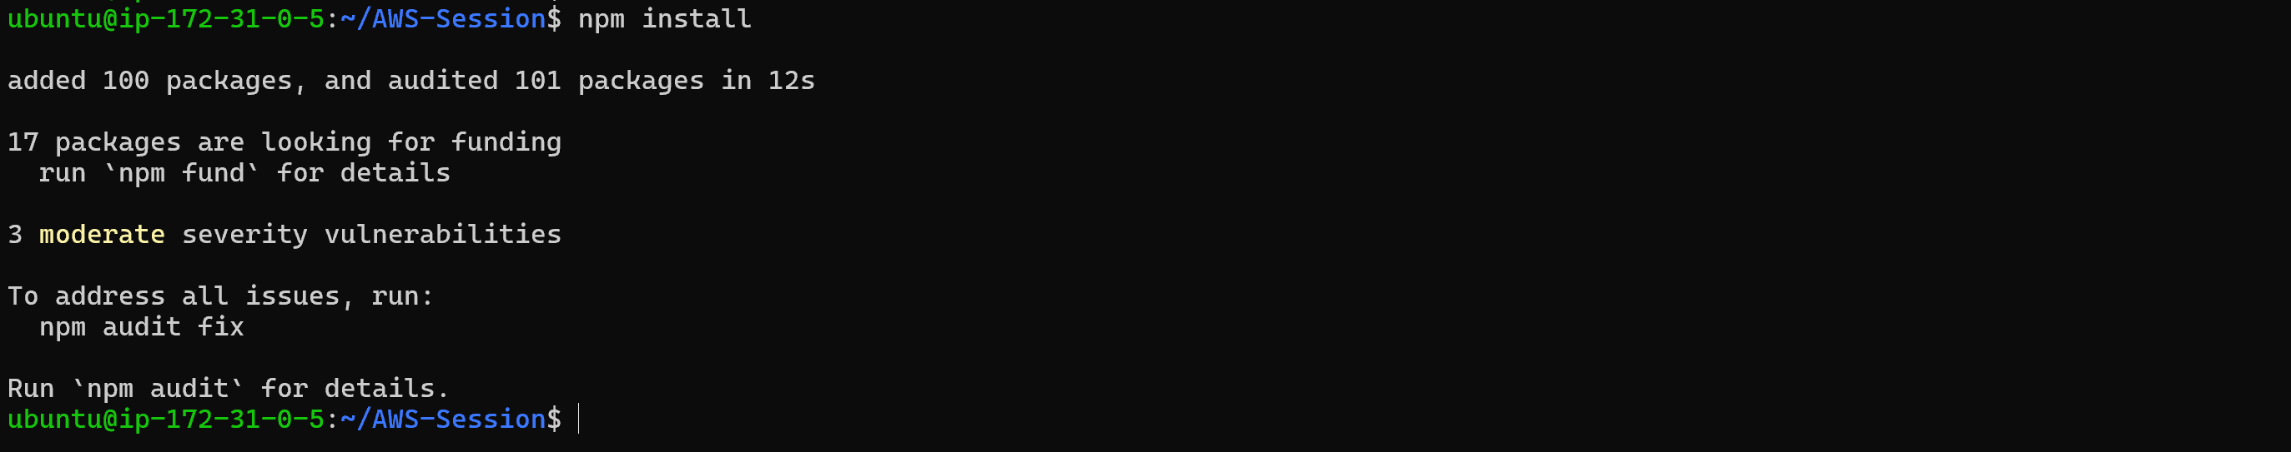

Now, we can start or app to run in localhost of ec2.

**Command:** npm run start

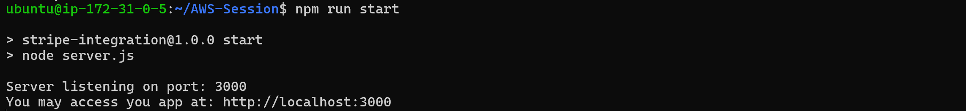

Means our app is running successfully in remote VM local. Let’s try to access it. URL in above screenshot will not work. Because it will check from your local PC not from remote VM. But our app is in EC2 instance.

Use this command: **Public IP of EC2:3000 🡪** 15.206.187.143:3000

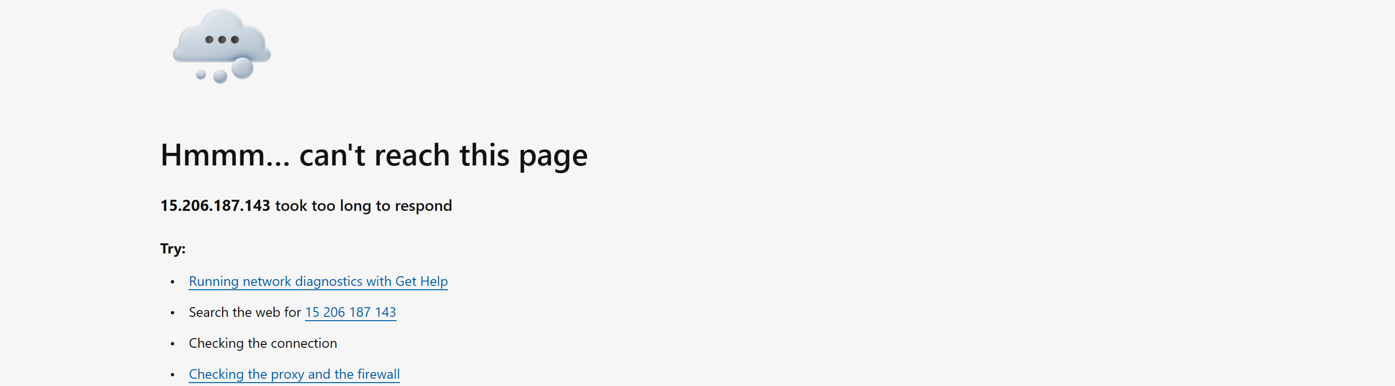

Since, we are trying to access it through Interneet – We have to expose our 3000 port to outside world / Internet.

**Note:** We will have to edit the **inbound** **rules (**incoming netwrok traffic**)** in the security group of our EC2, in order to allow traffic from our particular port

Select the EC2 instance from EC2 console and check security groups: 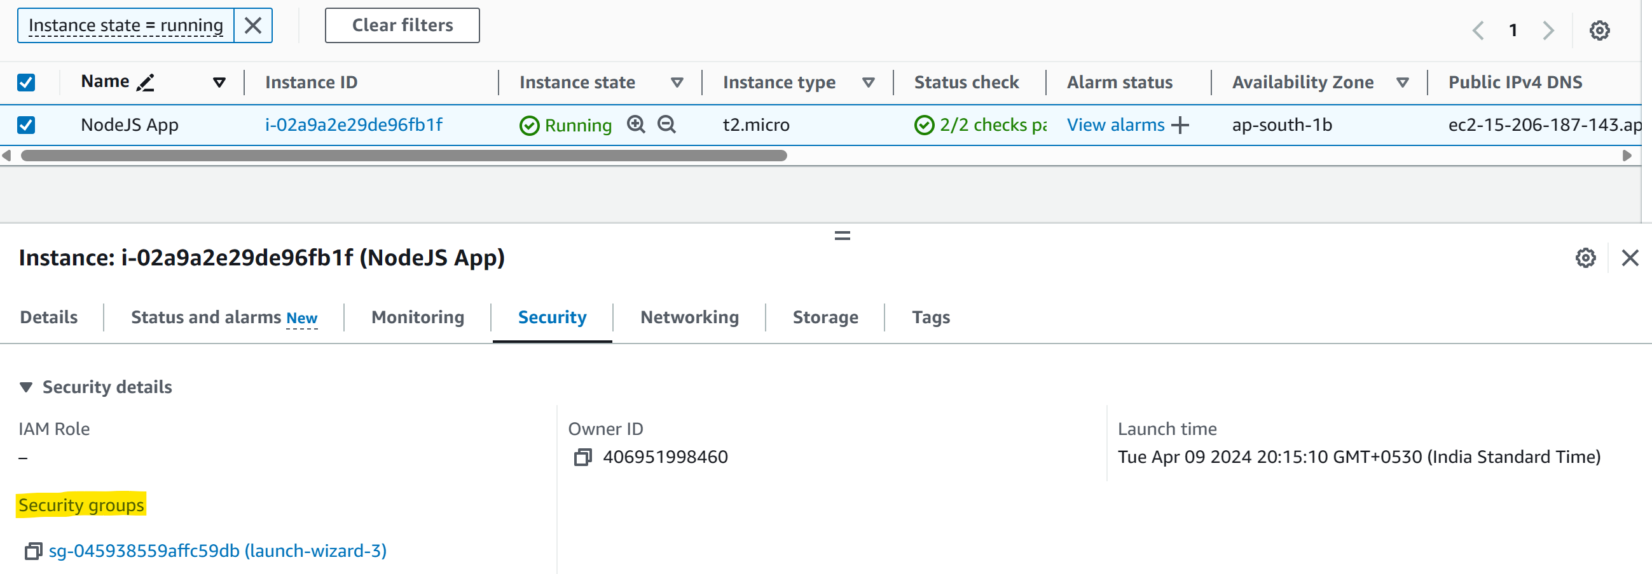

You will have current inbound and outbound rules. 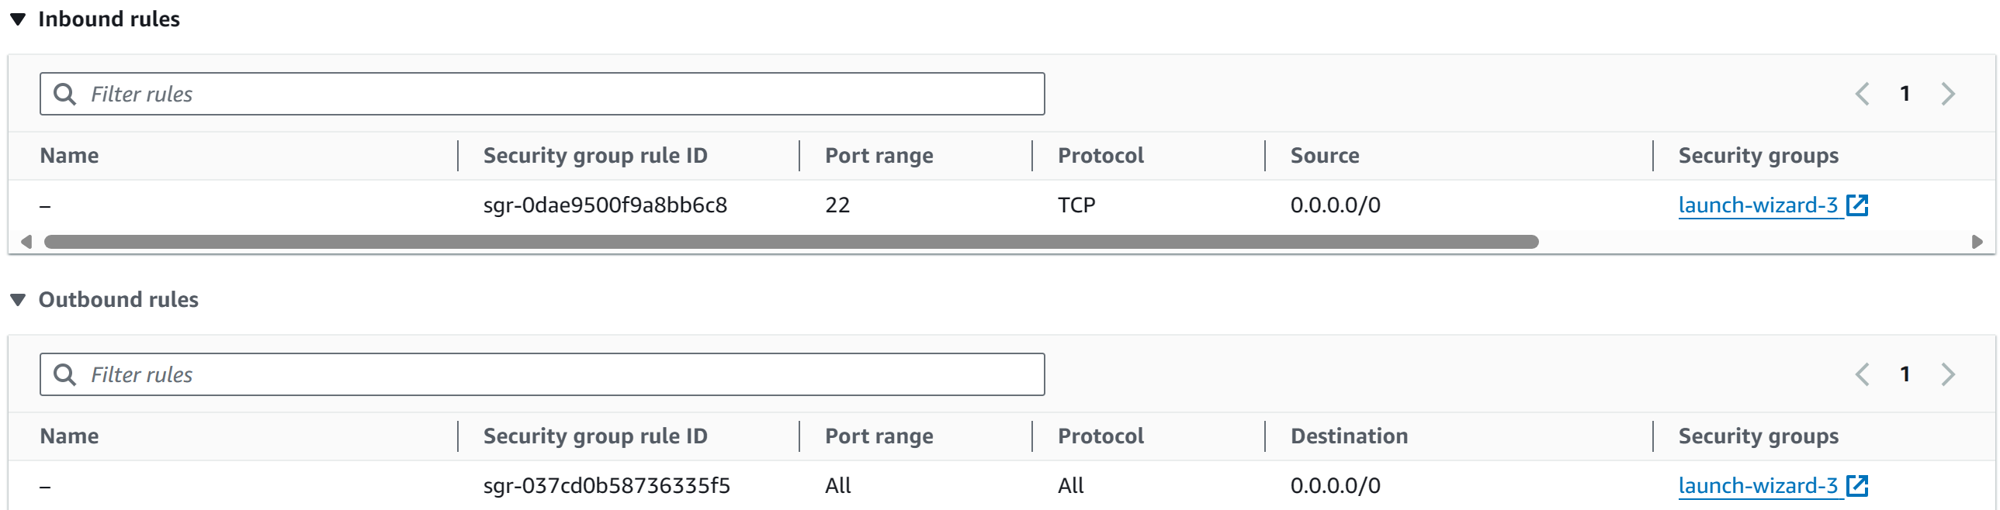

Click on that Security Group highlighted in yellow. 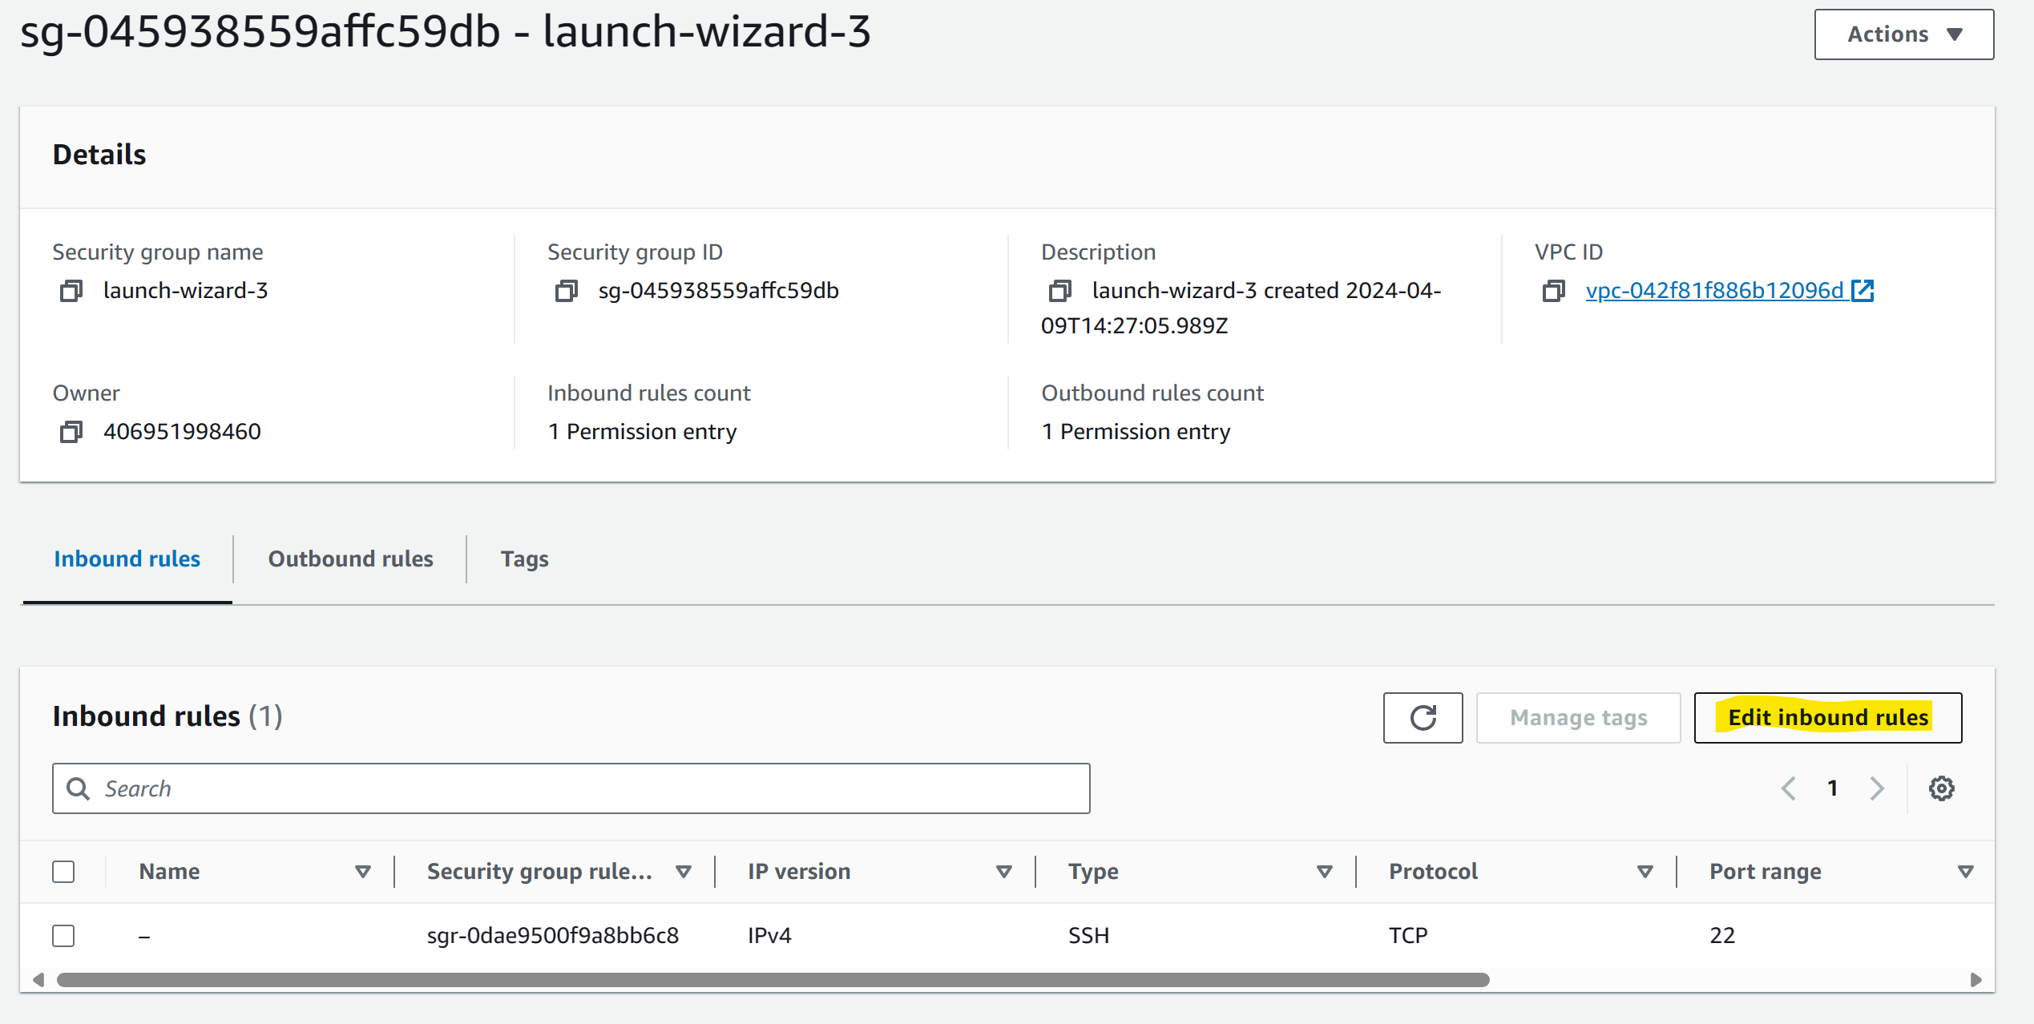

We have to edit the inbound rules, meaning we have app in our AWS EC2 which is running in 3000 port, and people from outside internet should be able to access it. So, we have to edit inbound rules of Security group. So that our app is exposed to Internet over 3000 port through the EC2 instance.

Add port 3000 and select the 0.0.0.0/0 in Source then it will auto select Anywhere. Save it.

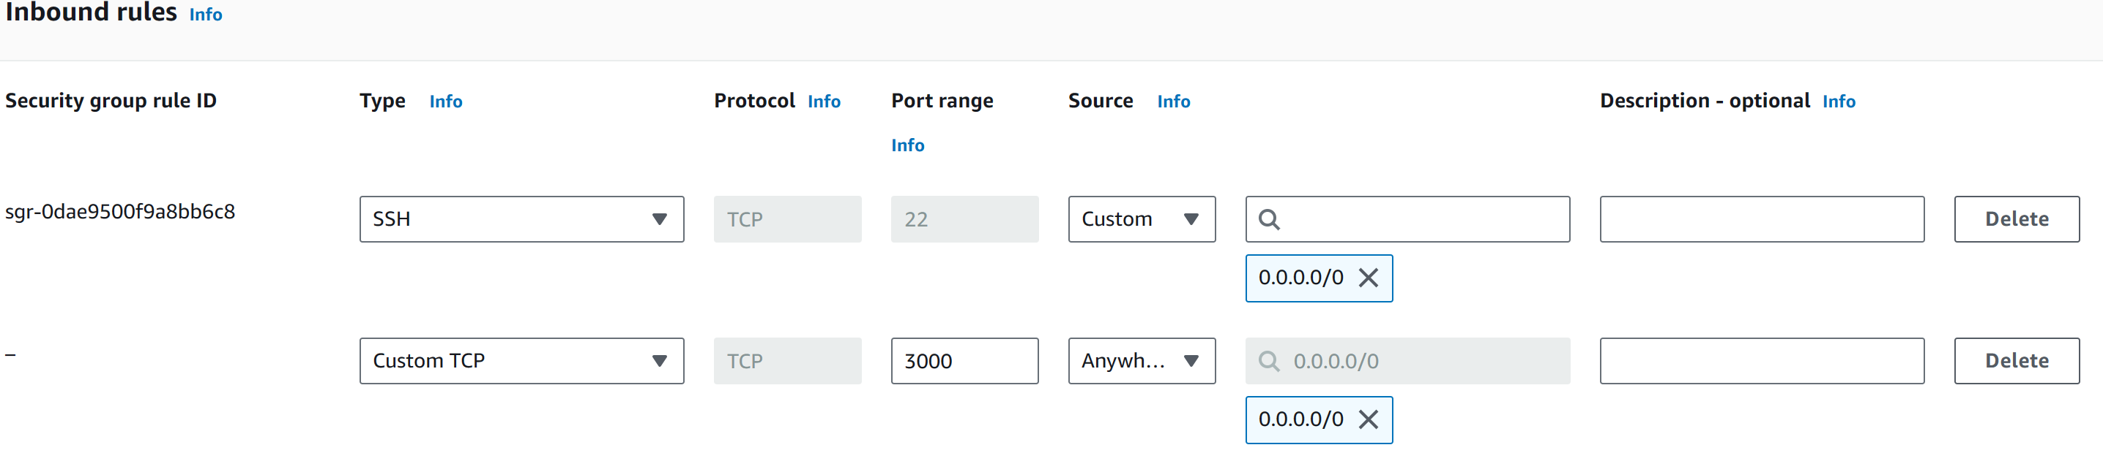Once saved, Inbound rules are updated now.

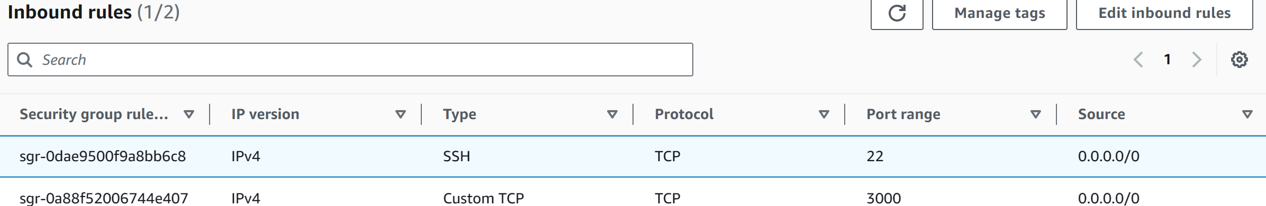

Now refresh the page, our app is exposed to open internet now.

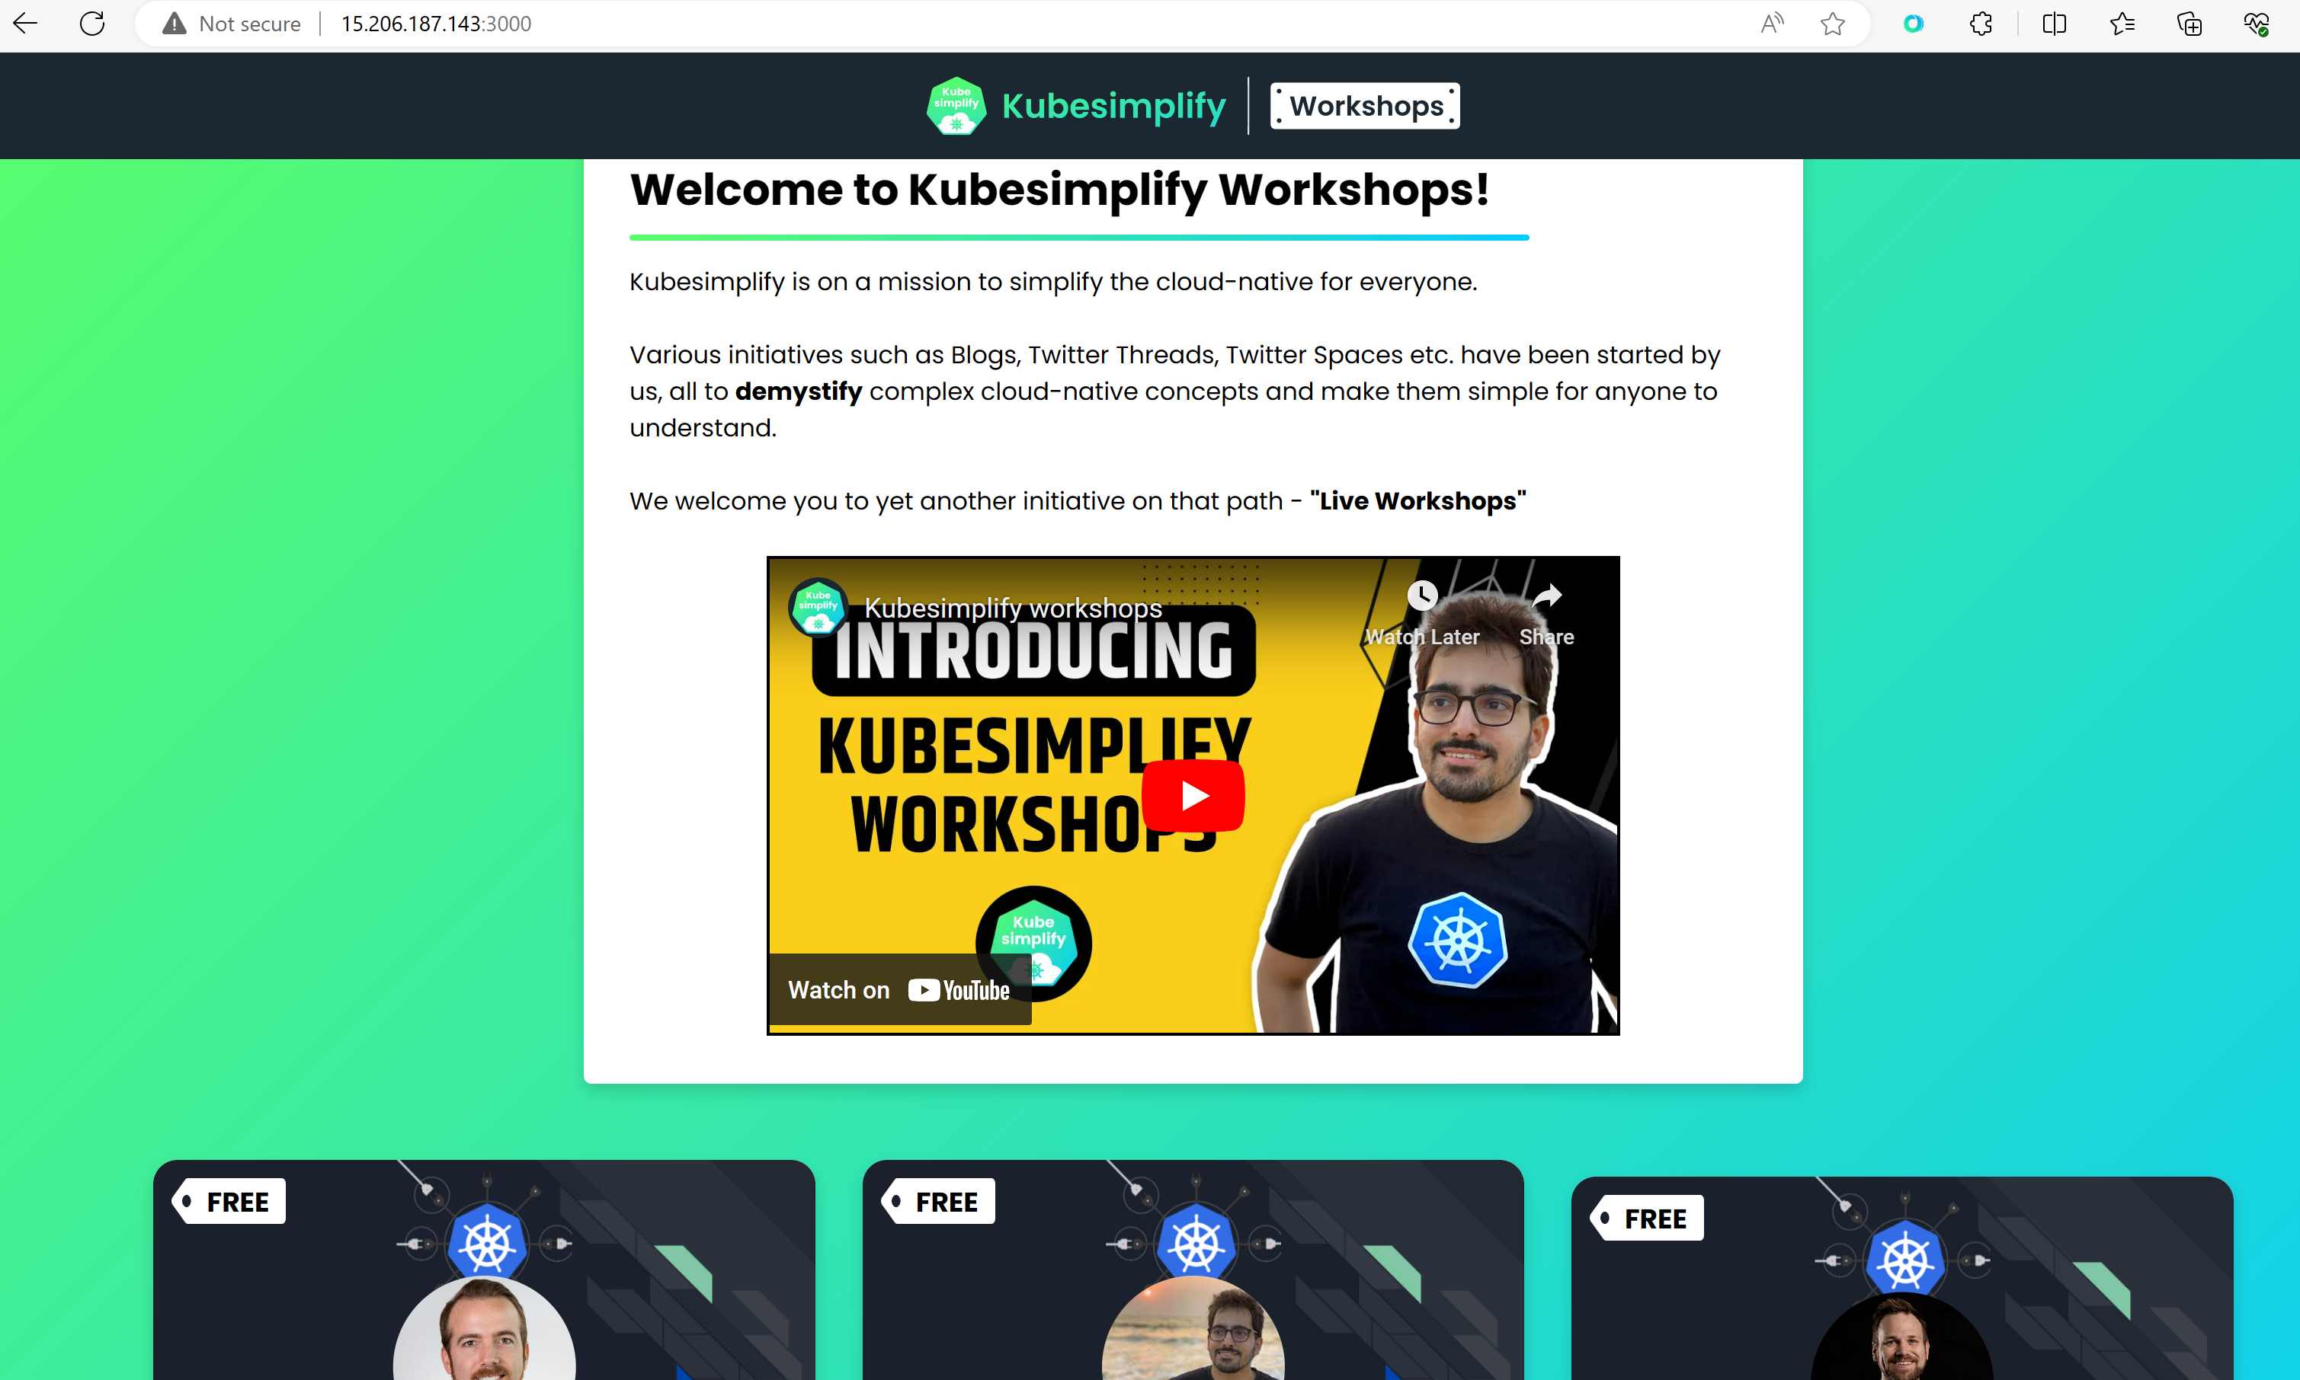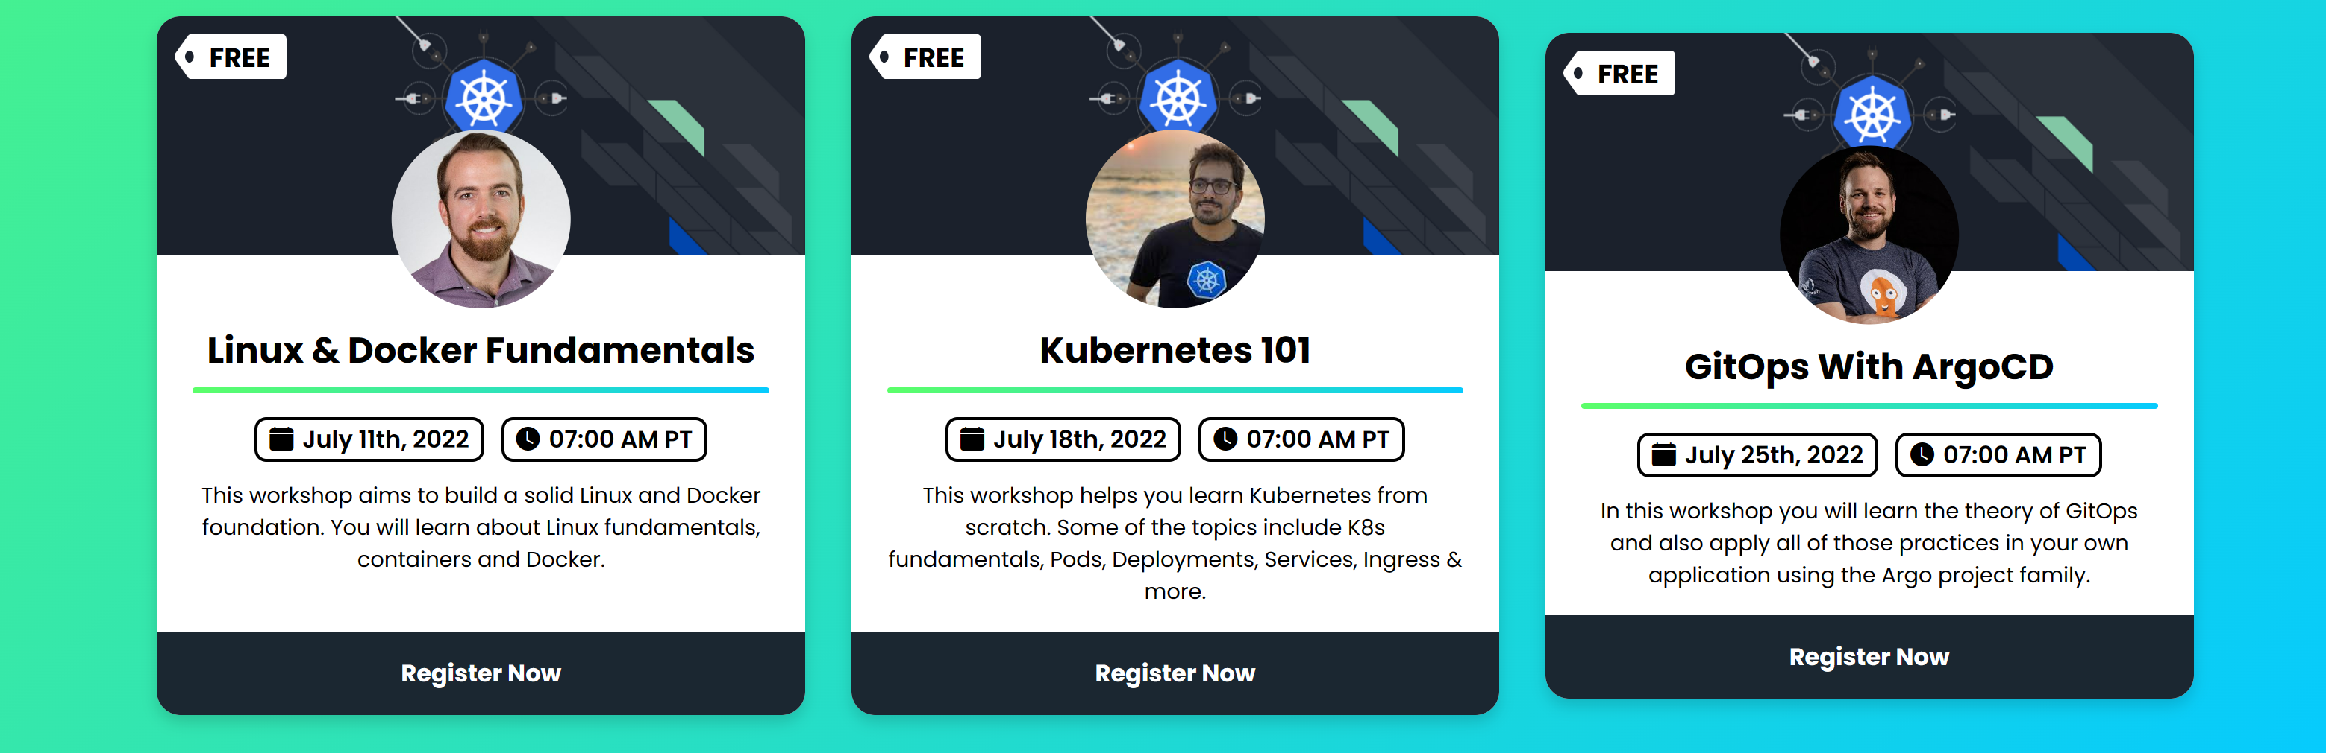

Press “CTRL + c” to stop the app running in localhost of VM.



On doing this app is not reachable again over Internet as well.



For this **project**, we'll have to set up an **Elastic** **IP** **Address** for our **EC2** & that would be our **DOMAIN**.